
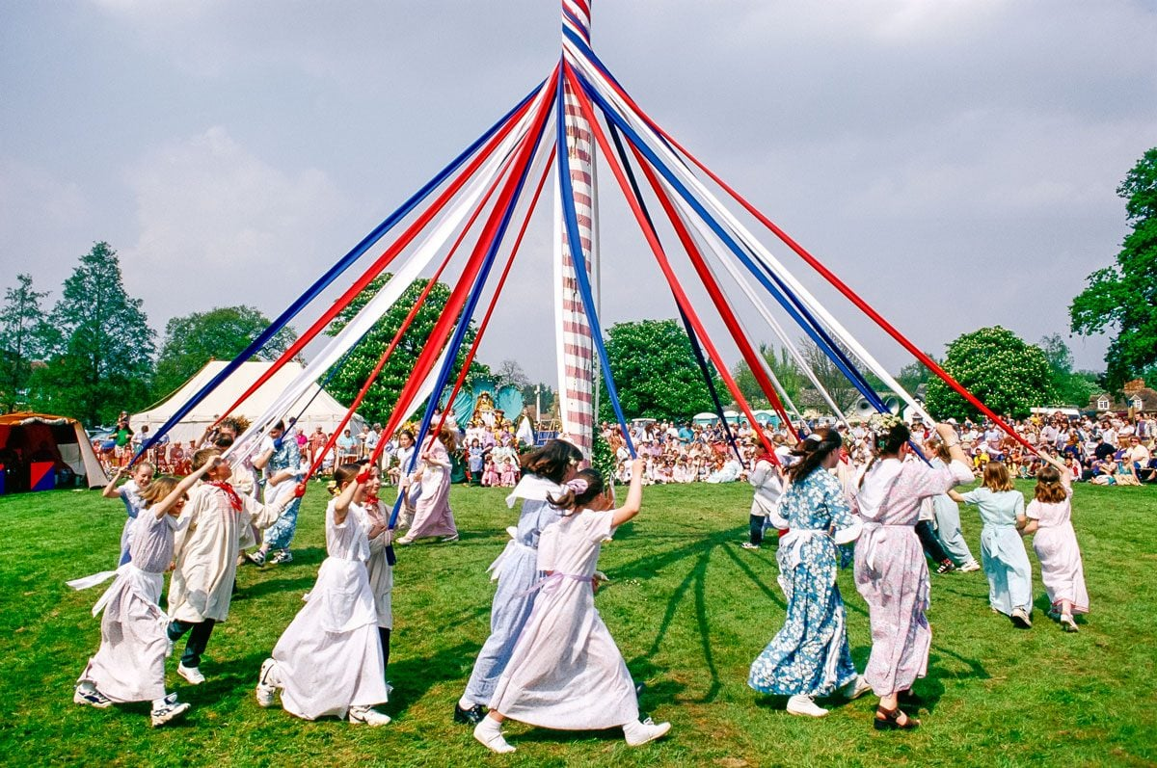
Dates to Remember
May
6 After noon at the library
8 Spa Day –2:00-Last day for “Little Books”
9 Elodie’s house, all are invited---families too
10 Mather’s Day
13 Early Out
14 Pa’s and Painting—2:00
15 Zoo Day—8:45 leave St. Mary’s
18 Spring Concert (UMM-6:00)
19 sixth grade vs senior kickball game
20 6th grade graduation
21 PreK & K graduation 2:00
22 Last Day—picnic at Wells Park, all invited (Plans could change)
Dress for the weather!! Layers are always good!
I am quite sure we are sending the children home pretty jazzed up as we celebrated May Day in great fashion! As a school we delivered May baskets to some of the area businesses and some around in school! Fun Day!
A wonderful week in the Kinder room—Eleanor had her baby that we have been anxiously waiting for and praying---Congratulations to the Chamberlains on Katheryn Marie joining your family.
We are finishing some workbooks but will still be doing work! You can tell the end of the school year is coming, the room is a little louder and the kids are a bit wilder. Keep reviewing all they have learned especially over the summer.
Library Cards should have made it home—Hope you find the time to use it.
As you probably have heard and witnessed, we have been practicing for Spa Day as well as graduation. Pa and planting invites for Father’s Day celebration should have also made it home—The kids are very excited to have you as guests to their school, as am I. More Zoo info will be coming home in the next week or two. Let me know if you have questions of any of the upcoming events.

KINDERFLASH
Friday, May 1st, 2026
Be Nice Because Nice Matters!

